_____**ANSWERS**____

PSYCHOLOGY ATAR

Task One

Topic Test

Biological Influences and

Bases of Behaviour

**Time: 45 minutes Score: /46**

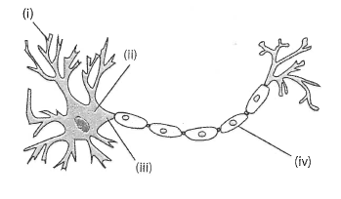The diagram below shows the structure of a motor neuron.

Structure of a motor neuron

1. Describe the purpose of the structure labelled at (i) in the diagram. (1 mark)

**To take impulses/messages away from CNS to muscles**

1. Identify the division of the nervous system in which a motor neuron would be found. (1 mark)

**Peripheral NS OR Somatic NS**

1. Name TWO neurotransmitters that are secreted in the brain. (2 marks)

**Any 2 of dopamine, serotonin, noradrenaline, acetylcholine, endorphins**

1. Briefly describe how neurotransmitters are transferred from one neuron to another. You may use an annotated diagram to answer this question. (4 marks)

**Neurotransmitter released from vesicle in axon ending (1)**

**Diffuses across the synapse (1)**

**Attaches to specific receptors on postsynaptic membrane/dendrite membrane (1)**

**Causes action potential to occur on membrane (1)**

**Fully annotated diagram correct = 4 marks**

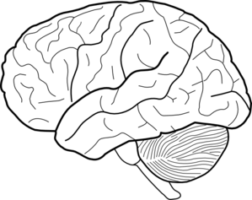

**A**

**B**

Referring to the diagram above, name parts A and B, and briefly explain how they work together to enable a person to respond to a bicycle bell being sounded while they are walking in the middle of a pathway. (5 marks)

**Part A = Temporal lobe (1)**

**Part B = Cerebellum (1)**

**Any 3 marks but must mention role of temporal lobe and cerebellum at least once for each**

**The sound of the bell would be transmitted/processed by temporal lobe (1)**

**Comprehension of the sound occurs in Wernicke’s area (1)**

**Person responds by moving out of the way/turning their head (1)**

**Cerebellum assists in the maintenance of balance/movement in one direction/refined motor coordination (1)**

___________________________________________________________________________

1. 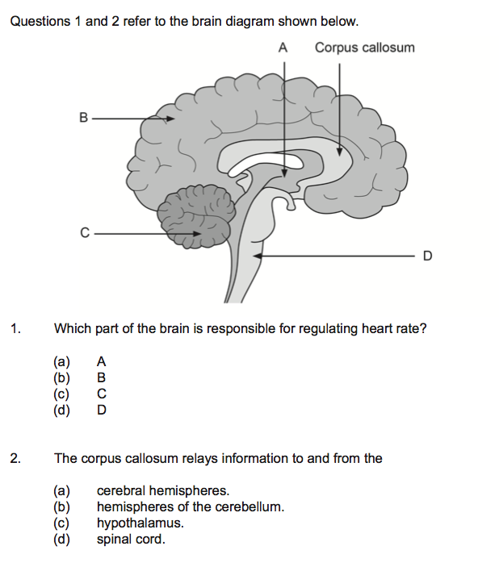Refer to the following diagram to answer the following questions.
2. Describe the structure of the corpus callosum and state its function. (2 marks)

**Structure = white/myelinated nerve fibres (1)**

**Function = allows communication between left and right hemispheres of cerebrum (1)**

1. Name the area of the brainstem labelled “D”. State two functions of D. (3 marks)

**Medulla oblongata (1)**

**Controls respiration/breathing; heart rate; blood pressure; sneezing and coughing 1 mark each for 2 (2)**

1. Name the structure that would be found at “A”. (1 mark)

**Thalamus (1)**

1. Use an arrow to indicate where the frontal lobe exists. (1 mark)

**SEE Picture**

1. State two functions of the frontal lobe of the brain. (2 marks)

**Memory formation/motor coordination/thought processes/problem solving/speech/language/social behaviour/personality**

**Any 2 for 1 mark each**

1. 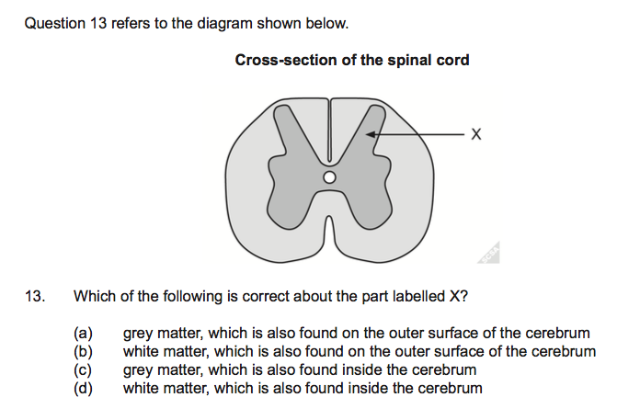The diagram above shows a section of spinal cord.
2. Identify the structural material that “X” is pointing to. (1 mark)

**Grey matter**

1. Name the main part of the brain where “X” would be found. (1 mark)

**On the outside/cerebral cortex**

1. State two functions of the spinal cord. (2 marks)

**Relay impulses/messages to and from the brain (1)**

**Spinal reflexes (1)**

The ‘flight or fight’ response happens when people are confronted with something that could potentially be dangerous.

* 1. Give one real-life example of a situation where the flight or fight response would occur. (1 mark)

**Any realistic situation such as a person sitting an exam/being scared by a snake**

* 1. Name one neurotransmitter responsible for this response. (1 mark)

**Noradrenaline (technically adrenaline is a hormone NOT a neurotransmitter)**

* 1. Provide two examples of changes to the way the human body functions as a response to fight or flight. (2 marks)

**heart rate increases/breathing rate increases/pupils dilate/bladder relaxes/blood diverted from digestive system Any 2 correct for one mark each**

1. a) If the occipital lobe of the brain was damaged, explain the possible effects a person may experience. (2 marks)

**Seeing “stars”/blindness/vision loss/hallucinations/illusions/inability to see colours (Any 2 correct for 1 mark each)**

b) If Wernicke’s area is damaged, explain the possible effects a person may experience.

(2 marks)

**Wernicke’s aphasia = poor auditory processing/inability to comprehend spoken language/inability to comprehend written language (Any 2 correct for 1 mark each)**

1. Using your knowledge and understanding of genetics, describe three examples of the effects of genetic factors on behaviour. (3 marks)

**Genetics determines personality (1)**

**Risk of addictive behaviour linked to genetics/inheritance (1)**

**Risk of developing mental illness linked to genetics (1)**

1. Complete this table on psychoactive drugs: (9 marks)

1 Mark for each correct answer

|  |  |  |  |
| --- | --- | --- | --- |
| **Class of drug** | **One (1) physiological effect** | **One (1) psychological effect** | **Example of a drug in this class** |
| **Depressant** | Slow body functions such as  Slow heart rate, slow breathing rate , decreased reflexes | Euphoria, reduced perception of pain | **Alcohol/**  **heroin** |
| **Stimulant** | Suppression of appetite, headaches, dizziness, vomiting | Euphoria, elevate mood, increased mental alertness, increased arousal | Caffeine/  nicotine/  amphetamines |
| **Hallucinogen** | Increased heart rate and blood pressure, lack of muscle coordination, convulsions, heart and lung failure | Senses of time, direction and distance are distorted, erratic and violent behavior, paranoia | PCP/ LSD/ Magic Mushrooms |

**END OF TEST**